For Immediate Release
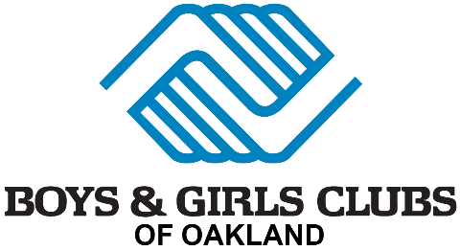

Oakland Youth Gain Access to Professional Recording Space with Opening of Digital Music Studio

Boys & Girls Clubs of Oakland Unveils Hi-tech Studio Funded by Unique Cross-Community Effort

OAKLAND, Calif. (April 13, 2026) — Youth in Oakland will soon have access to a professional digital recording studio designed to nurture creativity, confidence, and career pathways in music and media. The Boys & Girls Clubs of Oakland will officially open the Digital Music Studio on Wednesday, April 15, marking a significant investment in creative youth development in the community.

The new studio is a professionally designed space equipped with a custom-built mixing desk and commercial-grade recording equipment. It also includes an inspiring “Wall of Fame” showcasing artists and athletes including Usher, Jennifer Lopez, Denzel Washington, Michael Jordan, Ciara, Ne-Yo, and Jackie Joyner Kersey— all former Boys & Girls Club members whose success reflects the impact of access and mentorship. And Boys & Girls Clubs of Oakland longtime supporter and Oakland native Zendaya.

A Cross-Community Effort
Funding for the studio reflects a unique collaboration between communities. In November, supporters in Mill Valley raised more than $50,000 during the 4th Annual Texas Hold’em fundraiser, organized by co-hosts Jackie Chin and Gail Dunnett. Every dollar raised was earmarked for one thing: building a professional music studio inside the Boys & Girls Club of Oakland.

The fundraiser was held in partnership with Boys & Girls Clubs of America Trustee Jackie Chin and Gail Dunnet of the SUBVERS!VE Foundation, a nonprofit founded in memory of Harrison James Dunnett, a Mill Valley rapper, songwriter, and producer who passed away in 2016 at the age of 20. Harrison believed deeply in the power of music as a positive force. The studio honors his legacy by creating a place for young artists in Oakland.

"We hope this new studio will inspire kids to dream big and use their voices in a positive light," said Gail Dunnett, event co-chair and studio designer.

The project was made possible through contributions from multiple partners, including design by Gail Dunnett of Vesta, technical direction and equipment coordination by Paul Liszewski of Pure Music LIVE and professional equipment provided by Clair Global, custom engineering and a mixing desk from Coast Integrators, monitors and speakers from Kali Audio, and innovative lighting design by 2Modern. Together, these collaborations resulted in a fully immersive creative space where teens can explore music production, storytelling, and artistic expression.

“This studio gives our teens a professional space to discover who they are and what they’re capable of,” said John Mascali, President and CEO of the organization. “Beyond music, it reinforces everything we do — helping young people graduate with confidence, skills, and the tools to achieve their goals.”

Boys & Girls Clubs of Oakland’s Digital Music Studio Grand Opening Celebration:
- When: Wednesday, April 15, 5–7 p.m.

- Where: Boys & Girls Club of Oakland, 3300 High Street, Oakland, CA

- What: live DJ sets, guided studio tours, community leader remarks, Q&A with kids, and refreshments.

- Special Guest: Bay Area rapper and singer Fijiana, known for her Indo-Fijian heritage, will do a Q&A with kids. One of her most popular songs, Welcome to the Bay, highlights her connections to Richmond and Oakland.

- Who: Open to supporters, community members, and media.

- Registration: Please click here to register. All attendees must register for kid safety.

- Media Access: Media interviews and studio access available.

About Boys & Girls Clubs of Oakland
The Boys & Girls Clubs of Oakland serves thousands of young people each year with after-school and summer programs focused on academic success, leadership, healthy lifestyles, and good character.

About SUBVERS!VE Foundation
Founded in loving memory of Harrison James Dunnett (September 14, 1996 – December 31, 2016), the SUBVERS!VE Foundation supports young artists creating positive, non-violent, drug-free music — changing the world one song at a time.

Media Contact:
DeeDee Taft
deedee@spinpr.com, 415.515.1229
Spin Communications, Inc.
# # #

